Creating the Simple Collection Class

Creating a Simple Data Bound Collection 1
Creating the Properties 3
Re-Factoring 4
AllCounties & Count 9
Linking to the Presentation Layer 16

Creating a Simple Data Bound Collection
Let’s now have a go at something more complex.
The next class we will look at is clsCountyCollection.
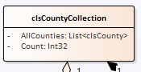
This class is associated with clsCounty so it makes sense to complete the pairing. The class is also an example of a collection class so we have the opportunity to think about some of the issues this creates.
Before we do anything complicated let’s get back to basics.
First we need to create a test class for clsCountyCollection, i.e. tstCountyCollection…
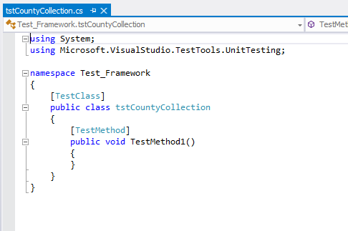
As before we need to test that we are able to create an instance of clsCountyCollection like so…
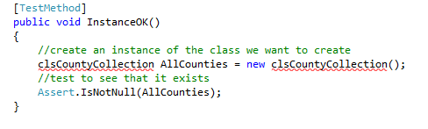
The test will fail – as it should.
Create the class in the class library…
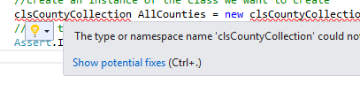
Followed by…
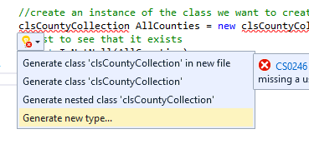
Then make sure you set the next screen up correctly…
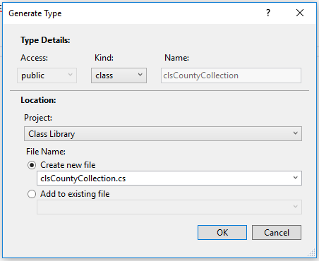
The test should now pass.

Creating the Properties
Next we want to create the properties…

Count is the simplest one so let’s do that first.
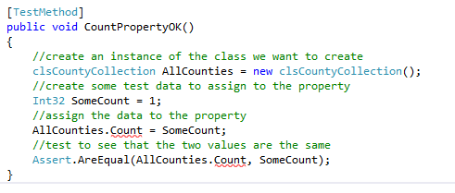
As usual the test will fail since the property has not been created.
So let’s do that now. As above show potential fixes followed by generate property…

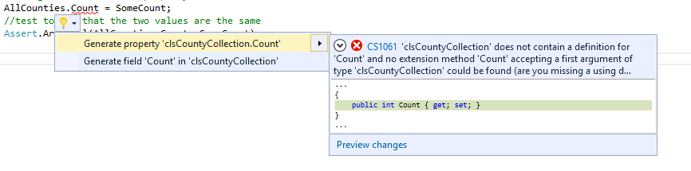

Should do the trick!

Re-Factoring
The important thing to appreciate with TDD is that it doesn’t actually matter if our tests are initially rubbish!
With all of the code we write, there needs to be a constant process of review called re-factoring.
In re-factoring we are constantly asking the question “is there a better way of doing this?”
In this next example we will see an example of this.
The next property we will create is the AllCounties array list.
When the class is completed this list will draw its data from the underlying database. The count property will also need to tell us exactly how many records there are in the list.
Linking the class to the database is a big jump even for an experienced programmer. Also making a big jump may sacrifice the quality of testing applied.
If we take small steps to solve the problem then we can test each step as we go and we won’t get overwhelmed by the scale of the problem.
First off let’s treat the property like any other property, ignoring the fact that it is going to be linked to the database.
The following code does this and it is worth spending a little while understanding what is going on.
Firstly we need to import the library code from the .NET framework allowing us to work with collections.
At the top of the test class add the following line of code…
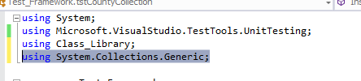
This will import the required features into the class.
Next we need to write the test method like so…
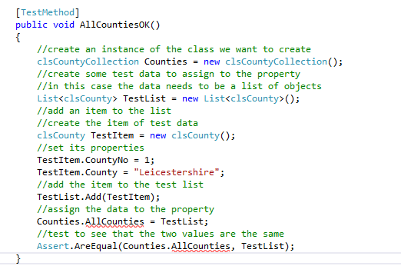
The test method will fail as we don’t yet have the property AllCounties.
Create the property exactly as you did in the previous examples.
It is important to understand what we have done here and how it works.
Firstly we create an instance of the class we want to test – nothing new here.
//create an instance of the class we want to create
clsCountyCollection Counties = new clsCountyCollection();
In this example creating the test data is a little more complicated.
//create some test data to assign to the property
//in this case the data needs to be a list of objects
List<clsCounty> TestList = new List<clsCounty>();
//add an item to the list
//create the item of test data
clsCounty TestItem = new clsCounty();
//set its properties
TestItem.CountyNo = 1;
TestItem.County = "Leicestershire";
//add the item to the test list
TestList.Add(TestItem);
Since we are testing a property that contains a list of data we need to test it with another list, in this case TestList.
First we create an instance of the test list
List<clsCounty> TestList = new List<clsCounty>();
Now we need to add an item to the test list so that we have one entry in the list like so…
//create the item of test data
clsCounty TestItem = new clsCounty();
//set its properties
TestItem.CountyNo = 1;
TestItem.County = "Leicestershire";
//add the item to the test list
TestList.Add(TestItem);
Once we have created the test data we may now assign the test list to the property we want to test…
//assign the data to the property
Counties.AllCounties = TestList;
Lastly we test to see that the property and the original test data match as we have done in previous examples…
//test to see that the two values are the same
Assert.AreEqual(Counties.AllCounties, TestList);
And after all this the test passes.
There is however one major problem. The test passes but the functionality isn’t behaving how we want it to.
This test proves that we may create a list in code and assign it to the property.
What we really want is for that list to be taken from the database and that data used to populate the list.
We also want the count property to keep track of how many items are in the list regardless of where the data is coming from.
So the question is where next?
We could write the code to link to the database but to be honest that’s sounds too hard.
I am going to opt to make the count property work correctly as it is an easy win.
The first step is to create a test that fails which tests that the number of items in the list is the same as the value of the count property.
The following code which is a variation on the previous example does this.
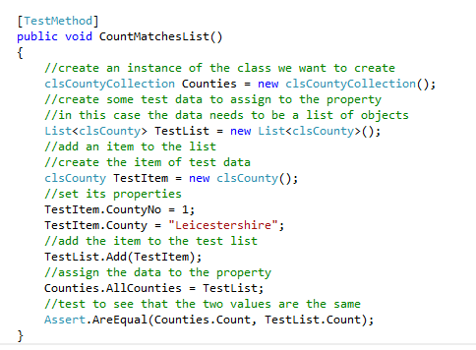

What we are doing is creating a list of test data with one county in it.
The count of this list is one.
This list is then used to set the list of the object Counties making them the same.
If everything is working correctly the Count property of Counties.Count should also be equal to 1 as it is using the same list.
We know that it is the same list because the previous test is checking it.
The problem is that when we run the test it fails.
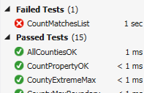
So where is the problem?
If we look at the code for clsCountyCollection we see the following auto generated code…
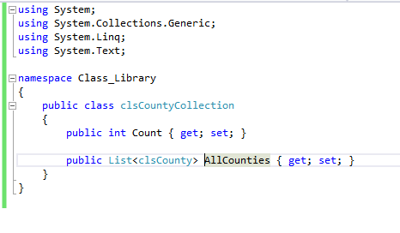
Let’s flesh this out to get the count property working correctly.
In object oriented programming we need to make sure our classes are correctly encapsulated.
What this means in English is that the inner workings of the object need to be hidden from other objects. Other objects will access the methods and properties of the object but have no access to the inner workings of the object.
To hide the inner workings of the class we use private data members to store the actual data.
The data in these private data members is made public via the public properties and methods of the class.
For the class we are creating clsCountyCollection we have two public properties

AllCounties & Count
In the code for the class we will need to create private data which does the job of actually storing the data for these properties.
The following code creates the first data member…
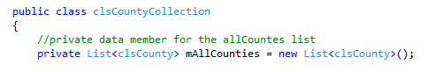
Note how we use the prefix “m” to remind us that it is a data member.
We now need to modify the auto generated code to make it does what we want it to do.
The first step is to link the public property AllCounties to the private data member allCounties like so…
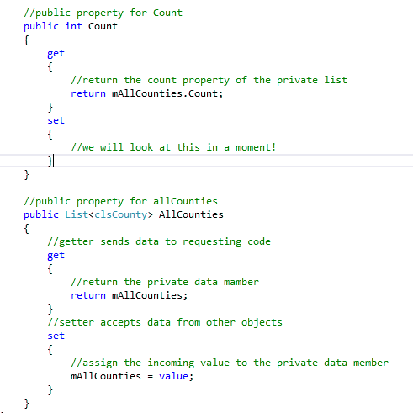
Run the tests and you should see no improvement from before. However it shouldn’t be any worse!

Notice how we simply return the Count property of the private list mAllCounties.Count.
This means that however many items there are in the list the count property should always report back the correct value.
Run the tests to see if everything passes.
There should be a problem.
The test CountMatchesList should work fine.
However the test CountPropertyOK is now failing.
This is going to happen a lot as we create half baked tests and refine them.
As our testing improves it will expose previous problems we hadn’t spotted.
So what is the problem with CountPropertyOK?
Let’s look at the code.
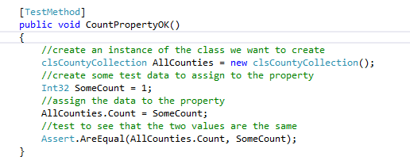
The issue with this test is that we are setting the value of SomeCount to 1. This assumes that there is one record in the list. The problem is that we are not adding any records in this test. This is good as it proves that the test framework is working correctly.
Change the code and all tests should now pass…
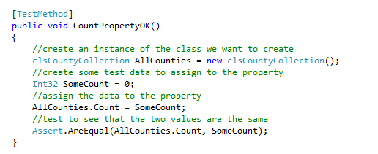

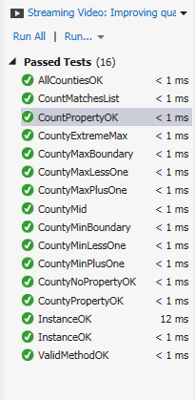
We may be reasonably sure that the count property is working as planned but we still need to get that database connectivity working.
So where do we go to next?
We need to think a little about how this class is going to work when fully implemented. Based on the testing created so far we are creating a list of counties and assigning that list to the collection. This isn’t quite right.
What we really want the collection class to do is to open the table in the database and populate the list automatically when we create a new instance of the class.
To make this work we need to access the constructor for the class and populate the list from there.
Let’s create a new test to test if there are two records already present in the class upon creating an instance.
Create the following test…
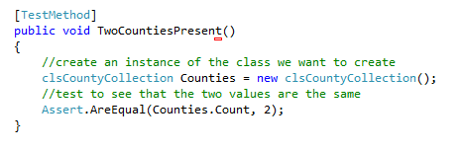
And watch it fail…
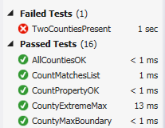
So let’s think about the code for the test and what it does (or more importantly doesn’t do!)
The first line creates an instance of the class called Counties
clsCountyCollection Counties = new clsCountyCollection();
The next test asks the question “are there two records?”
Assert.AreEqual(Counties.Count, 2);
OK- but the issue at this stage is that the records are not being created in this test. So where do we place the code that creates the two test records?
The answer is that we need to add a constructor to the class clsCountyCollection like so…
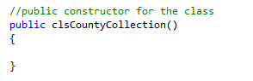
The constructor is a function that runs when the class is created. We place in the constructor code that is used to initialise the class upon instantiation. To create the constructor in C# we use the public keyword and then name the function so that it is the same as the name of the class.
The code for adding the two records needs to be written in this function.
The code to add the two test records is as follows…
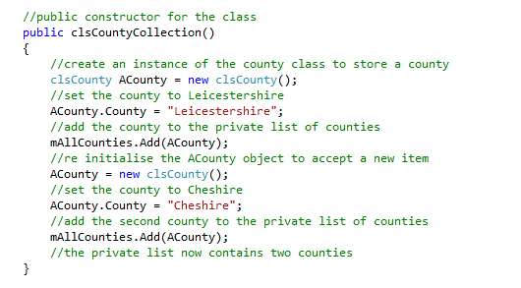
If you run the test you will see that you have fixed one problem only to create a new problem…
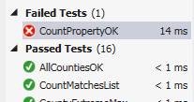
The test for CountPropertyOK is now failing – why?
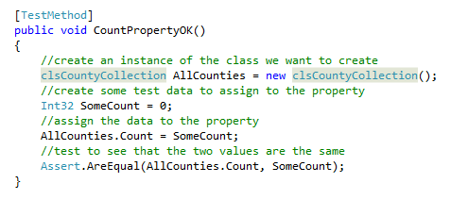
This test is fine so long as there are no items being generated as the object is instantiated.
The problem we have now is that having added two records created in the constructor this test will fail as it assumes there are no records upon creation of the object.
We could fix the test like so…
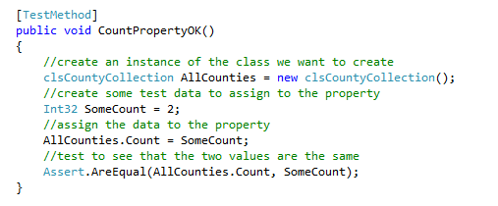
Making the test data to 2 rather than 0!
Run all tests to make sure everything is working correctly.
We now have a collection class which auto populates with two test records with a working count property.

Linking to the Presentation Layer
In the sample address book you should see following page AnAddress.aspx…
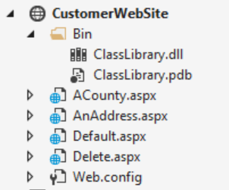
Which in design view looks like this...
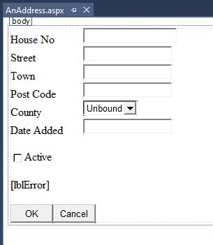
The bit that we want to make work is the drop down list of Counties…
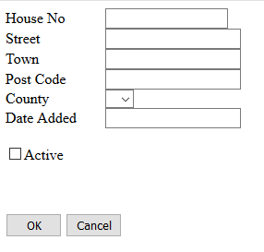
Make sure you have stopped the program, right click on the web form and select view code...
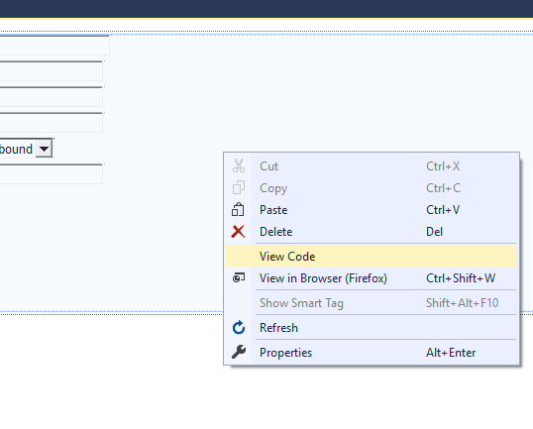
You should see the following code...
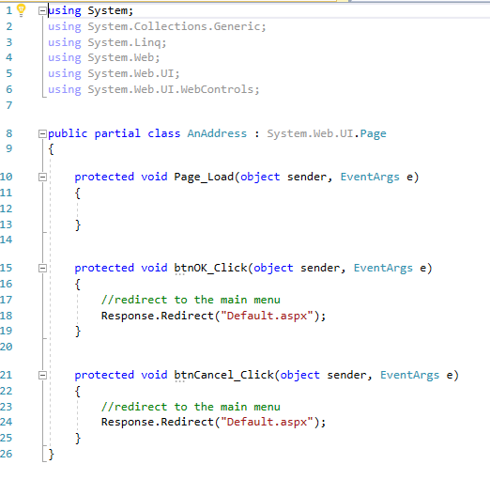
Create a new function called DisplayCounties …
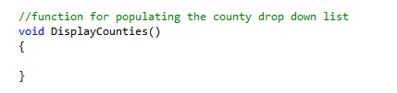
Like so...
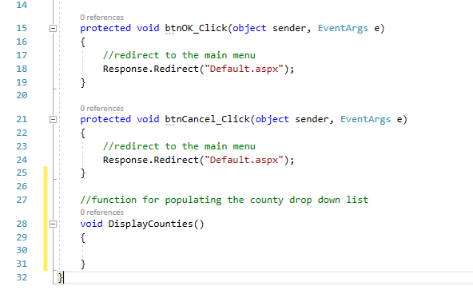
Inside the function create the following code to populate the drop down list with data…
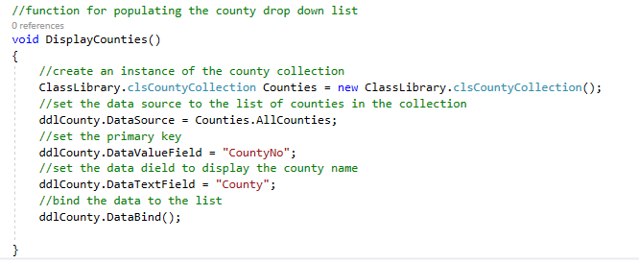
Next make a call to the new function in the load event of the form…
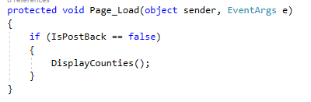
Notice how we use IsPostBack to check if this is the first time the page is displayed. If this is not the first time the page is displayed i.e. a post back we don’t want to refresh the drop down list.
If you run the form now you should see the drop down list populated with the data from the collection class.
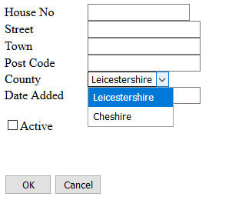
It is worth spending a bit of time to think about what has been achieved here.
We have:
- Taken a class diagram
- Created classes from that diagram
- Implemented methods and properties
- Linked the code to the collection class
- Linked the resulting code to the presentation layer
- Built a test project allowing us to be reasonably confident that the code is correct
The next stage of the work will make the link to the database.

